**Year 12 Human Biology**

**Unit 4: Test – Evidence for Evolution (5%)**

Name _________________________________________

Teacher_________________________________________

**Task 9**

**TYPE:** Test

**TIME:** 50 minutes

Multiple Choice: 8 marks

Short Answer: 32 marks

Extended Answer: 6 marks

TOTAL 46 MARKS

**Do not write on this question booklet**

**Do not turn page until instructed to do so**

**Section A: Multiple Choice (8 Marks)**

Answer all questions by shading the most correct answer on the multiple choice answer sheet.

1. Artefacts differ from fossils in that artefacts:

(a) are found associated with human remains

(b) are made of organic material that can be carbon dated

(c) are objects produced by hominins for a particular purpose

(d) are works of art with religious significance

Question 2 refers to the diagram below of the half-life of Potassium (K)-40.

1. Potassium-40 decays into Argon-40. If a sample was found to be 3.2 billion years old, what approximate percentage of Argon-40 would be present?

(a) 80%

(b) 90%

(c) 60%

(d) 20%

1. The main limitation of potassium-argon dating is that:
2. it can only be used to date fossils over the age of 2 million years.
3. it cannot be used to date fossils younger than 100,000 years old.
4. it can only date sedimentary rocks.
5. it can only date organic substances.
6. The half-life of Carbon-14 is approximately:

(a) 10 430 years.

(b) 7250 years.

(c) 5730 years.

(d) 4780 years.

1. Mitochondrial DNA is inherited from:

(a) both mother and father.

(b) only the father.

(c) only the mother.

(d) neither mother or father.

Question 6 and 7 refers to the diagram below.

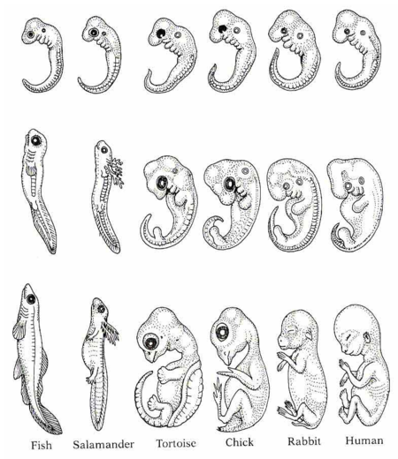

1. The diagram above represents embryos of six (6) vertebrate species over several weeks’ development. The study of comparative embryology provides evidence of a common ancestor by noting that:

(a) the more closely two species are related, the later in development these differences arise.

(b) the more closely two species are related, the earlier in development these differences arise.

(c) the more distantly two species are related, the later in development these differences arise.

(d) the more distantly two species are related, the fewer differences will arise.

1. The two vertebrates that have the most closely related ancestor are the:
2. human and chick.
3. human and tortoise.
4. fish and salamander.
5. salamander and rabbit.

Question 8 refers to the illustration below.

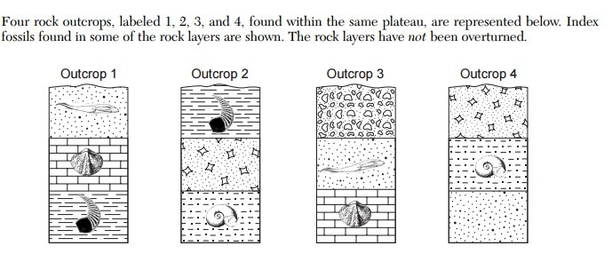

1. Which of the following statements regarding the ages of the sedimentary rock layer outcrops is correct?
2. Outcrop 1 is the oldest, Outcrop 2 is younger than 4.
3. Outcrop 4 is the oldest, Outcrop 3 is younger than 1.
4. Outcrop 2 is the oldest, Outcrop 3 is younger than 1.
5. Outcrop 3 is the oldest, Outcrop 1 is younger than 4.

**End of Section A**

**Year 12 Human Biology**

**Unit 4: Test – Evidence for Evolution (5%)**

Name _________________________________________

Teacher_________________________________________  
 **Task 9**

**TYPE:** Test

**TIME:** 50 minutes

TOTAL /46 MARKS

**Multiple choice & Answer booklet**

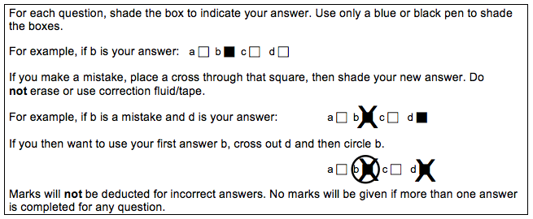

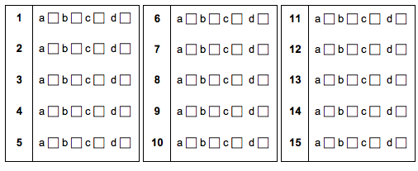

**Section B: Short Answer (32 Marks)**

Answer all questions in the spaces provided.

**Question 9 (6 marks)**

Use the diagram below to answer the following questions.

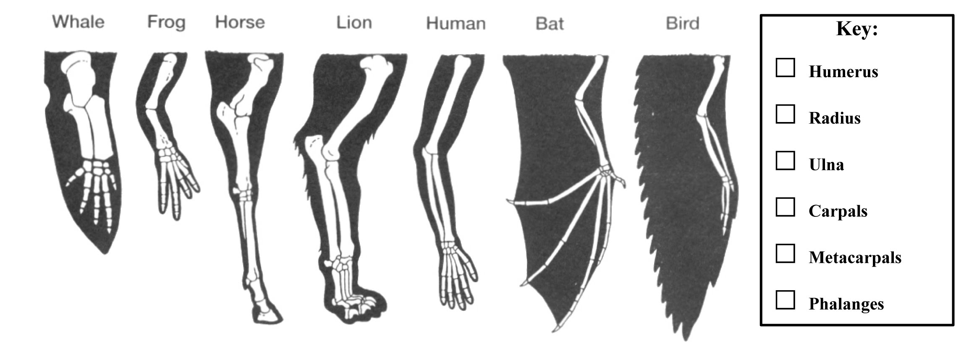

1. Name the type of evidence of evolution shown in the diagram. (1 mark)

______________________________________________________________

1. Explain how the diagram above provides evidence for evolution. Use specific examples in your response and reference relevant mechanisms of evolution. (5 marks)

______________________________________________________________  
  
 ______________________________________________________________

______________________________________________________________

______________________________________________________________

______________________________________________________________  
  
 ______________________________________________________________

______________________________________________________________

______________________________________________________________

______________________________________________________________

______________________________________________________________

**Question 10 (13 marks)**

Archaeologists were comparing volcanic rock strata and found ancient tools in Germany that they believe belong to *Homo* *neanderthalensis*, an early human ancestor.

(a) Suggest which relative dating method could be used for these tools. (1 mark)

______________________________________________________________

(b) Explain how archaelogists are able to provide an absolute date for these tools. In your response, name a radiometric method which may be suitable. (3 marks)

______________________________________________________________  
  
 ______________________________________________________________

______________________________________________________________

______________________________________________________________

______________________________________________________________

Some fossils of Aboriginal people were found in Victoria, very close to a river. The fossils were dated and found to be 50,000 years old.

1. Name and explain the process of the absolute dating method which would have been used to date these fossils. Include in your response how to calculate the age of the specimen using this technique. (6 marks)

______________________________________________________________

______________________________________________________________

______________________________________________________________

______________________________________________________________

______________________________________________________________

______________________________________________________________

______________________________________________________________

______________________________________________________________

______________________________________________________________

______________________________________________________________

______________________________________________________________

______________________________________________________________

1. The fossil record is incomplete and does not account for all of the organisms that have existed. Describe three reasons for the incomplete nature of the fossil record. (3 marks)

____________________________________________________________________________________________________________________________________________________________________________________________________________________________________________________________________________________________________________________________________________________________________________________

____________________________________________________________________________________________________________________________

**Question 11 (10 marks)**

Comparative studies in anatomy and biochemistry can provide evidence of evolutionary relationships.

Parts (a) and (b) refer to the table below showing the differences in amino acids in the Cytochrome C protein sequence between humans and other species of animals.

|  |  |
| --- | --- |
| Species compared with humans | Number of differences in amino acid sequence compared with human Cytochrome C |
| Chimpanzee | 0 |
| Gorilla | 0 |
| Rhesus monkey | 1 |
| Rabbit | 9 |
| Tuna fish | 21 |

* 1. Name an alternative/general term for proteins such as Cytochrome C. (1 mark)

______________________________________________________________

* 1. Describe how this data can provide evidence for evolution. (3 marks)

______________________________________________________________  
  
______________________________________________________________

______________________________________________________________

______________________________________________________________

______________________________________________________________

______________________________________________________________

______________________________________________________________

______________________________________________________________

* 1. Using wisdom teeth and body hair as examples, explain why these are considered vestigial organs and can provide evidence of evolutionary relationships. Include the definition of vestigial organs in your answer. (5 marks)

______________________________________________________________  
  
______________________________________________________________

______________________________________________________________

______________________________________________________________

______________________________________________________________

______________________________________________________________

______________________________________________________________

______________________________________________________________

______________________________________________________________

______________________________________________________________

______________________________________________________________

______________________________________________________________

* 1. Outline why vistigal ograns often reduce in size. (1 mark)

______________________________________________________________

______________________________________________________________

**Question 12 (3 marks)**

Non-coding sequences of bases in the DNA have been termed “Junk DNA” as it was initially thought that they had no function.

1. Name an example of “Junk DNA” which can be compared between specimens. (1 mark)

______________________________________________________________

1. Outline how this provides evicence for evolution. (2 marks)

______________________________________________________________

______________________________________________________________

______________________________________________________________

______________________________________________________________

______________________________________________________________

______________________________________________________________

**End of Section B**

**Section C: Extended Answer (6 Marks)**

Complete ALL of the following questions, and answer below.

**Question 13**

Discuss the importance of the fossil record in providing evidence for evolution. In your answer describe how fossils form. (6 marks)

___________________________________________________________________  
___________________________________________________________________  
___________________________________________________________________  
___________________________________________________________________

___________________________________________________________________  
___________________________________________________________________  
___________________________________________________________________  
___________________________________________________________________  
___________________________________________________________________  
___________________________________________________________________  
___________________________________________________________________  
___________________________________________________________________  
___________________________________________________________________  
___________________________________________________________________  
___________________________________________________________________  
___________________________________________________________________  
___________________________________________________________________  
___________________________________________________________________  
___________________________________________________________________  
___________________________________________________________________  
___________________________________________________________________